Student name – student number

Cover page

**Above all else, read the two PDF documents carefully, this document is to help you get started. Make sure you address everything in the assignment brief.

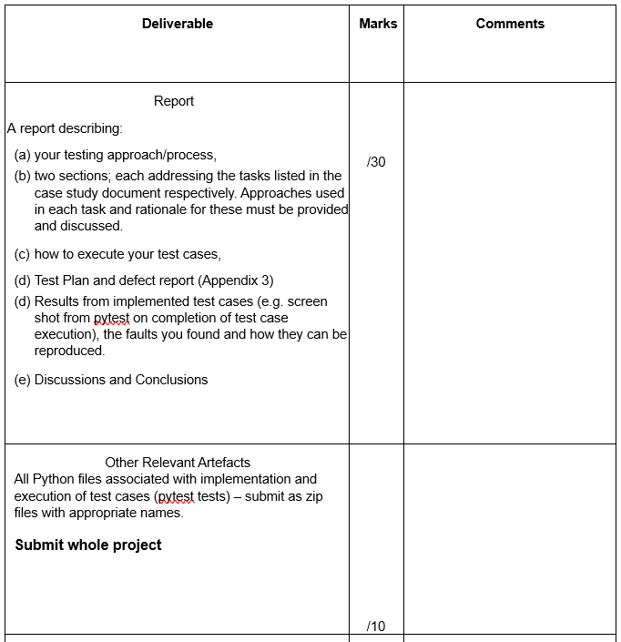
**Follow the marking guide, make sure you address everything on that. Below are some ideas.
- Read the slides from Module 4 for more hints

Introduction
Introduce the aims and intent of the software testing document, examples for points to talk about below. (1-2 paragraphs)
- What are you testing?
- How are you testing this software?
- What criteria are you using?
- Aims?
- Scope?

Testing Approach
Items, tools, overall approach (methodology?)

Test Plan

Questions 1
- What are you doing to address back-box testing ect?
- Your test cases and tables associated with them
- Short commentary and summary on results
Inputs
ID | Input 1 | Input 1 | Input 3 | xxx | xx | xx | x | x | xx | Input n | Input n+1
SM1 | 1 | 6 | 10 | 9 | 10 | ML18.330 |  | Mark Colin | done | Desc | 0
SM2 | 1 | 6 | 10 | 9 | 10 | ML18.33 | ML18.330 | Mark Colin | done | Desc | 0
SM2_alt | 1 | 6 | 10 | 9 | 10 | ML18.33 | cancel |  |  |  | 0

Observations
Id | Test Type | Expected  Result | Actual  Result | Description of defect/fault | Comment
SM1 | E | Valid string 1
SM2 | E | Valid string 1
SM2_alt | E | ..

- Valid string 1 - Meeting booked.
- Valid string 2 - …
- THESE ARE OBSOLETE TESTS BEFORE THE SOFTWARE CHANGED, USE AS A GUIDE ONLY
- You can also test by having files of output
- There are many ways to do this!!

Question 2
- What are you doing to address structure testing ect?
- Your test cases and tables associated with them (paths, input etc)
- Short commentary and summary on results

Test case execution
Think of this is something you will need to pass onto another person if you left the company or moved to a different role.

Defect report

Defect Report

- What defects or abnormalities were found? (put in a table)
- Any special events for further investigation?
- Did you find extras?
- Did you find all existing one?

Results

- Document the tests you have run
- Screen shots of automated tests

Found errors
- List in simple terms the errors found

Conclusion
Summary of the testing process (evaluations, thoughts, adequacy, your confidence, future improvements to testing etc..)

